Dear President,

As the chair of the Organizing Committee of the 2024 Asian Youth Archery Championship to be held on 27th September to 03rd October 2024. I would like to invite you all to the most important archery events which takes place in Taipei, Chinese Taipei.

Taipei City is perfectly suited for hosting this event. Since we have hosted 2017 Universiade and many archery events, now we are ready to host the 2024 Asian Youth Archery Championship.

Taipei City is made up of mostly plains, interconnected mountains and plateaus. It has a deeply ingrained culture of service based on the friendliness, respect and warmth of its people. Local government and institutions are fully committed to the city’s development. Its modern infrastructure offers absolute comfort when hosting international class events.

Please find enclosed the necessary information for the event. We are looking forward to welcoming you and your team.

“Come and discover hundreds of reasons to visit and endless excuses to come back”. Sincerely yours,



# Ping Kun (Peter) CHIU

**OC President of 2024 Asian Youth Archery Championship**

# IMPORTANT DATES

Please find enclosed detailed information regarding this event. To register participation, please complete all the necessary sections in WAREOS (https://extranet.worldarchery.sport) within the deadlines listed below.

**Summary of deadlines:**

Registration Opening date on WAREOS 15th May 2024 Preliminary Entries 27th June 2024

Final Entries 31st August 2024

Late entries fee 6th September 2024

Hotel reservation down-payment (50%) 27th June 2024

Hotel reservation and payment 27th June 2024

Transportation 27th June 2024

Visa support 27th July 2024

Full refund cancellation deadline

15th July 2024

Please respect the stated deadlines.

\*After this deadline, the LOC is allowed to retain all amounts due by the Member Association

# PRELIMINARY PROGRAMME

|  |  |
| --- | --- |
| 26 September  Thursday | Arrival of participants Practice field available |
| 27 September  Friday | Official Practice / Equipment Inspection Team Managers Meeting |
| 28 September  Saturday | U21 and U18 Ranking Round |
| 29 September  Sunday | U21 and U18 Individual |
| 30 September  Monday | U21 and U18 Team |
| 1 October  Tuesday | U21 and U18 Mixed Team |
| 2 October  Wednesday | U21 and U18 Compound Finals |
| 3 October  Thursday | U21 and U18 Recurve Finals |
| 4 October  Friday | Departure of teams |

**NOTE: This preliminary program is subject to change according to participation**

# PRELIMINARY & FINAL REGISTRATION

All entries, accommodation reservations, transport needs, flight arrival/departure information and visa invitation letter requests are to be completed using the World Archery Online Registration System WAREOS https://extranet.worldarchery.sport. This system handles the entire registration process for this event. No entry forms, hotel reservations or transportation forms will be accepted; all information must be entered into WAREOS.

Member Associations can login to WAREOS at [http://extranet.worldarchery.sport](http://extranet.worldarchery.sport/) with the username and password assigned by World Archery. After entering WAREOS, selecting the event from the list will allow a member association to register their athletes. Select/press the “Entries” button to see the list of categories in the event. Select/press the “category” to enter the athlete and official numbers/details participating for that event. A WAREOS User Manual can be downloaded in PDF format (English) upon login.

Contact [wareos@archery.sport](mailto:wareos@archery.sport) with any questions regarding **technical problems on WAREOS**. For any question regarding the organization of the event (transport, accommodation, meals, invoices, visa etc.) please directly contact **the LOC**.

Athletes from a minimum of 4 different Member Associations shall be registered and participate in the event.

A maximum number of four (4) athletes per country can be registered into each category and divisions of the event.

Member Associations can only use WAREOS to make any changes or amendments to entries and will be able to do so at any time. An email will automatically notify the Organizing Committee and Member Association of any changes made in WAREOS.

\*Category U21 for Athletes born after 2004/01/01 (YYYY/MM/DD)

Category U18 for Athletes born after 2007/01/01 (YYYY/MM/DD)

# ENTRY FEES

Individual 200 USD per athlete

Official 150 USD per person

Any changes made after the deadlines specified or if entries differ by more than 4 athletes from the preliminary entries, the following penalty fees to will automatically be applied:

# PENALTY FEES TO BE PAID TO ORGANISING COMMITTEE

**Penalty fees for Late Entries (after final deadline): 50** per entry

**Penalty fees for not filling Preliminary entries 50** per entry

**Penalty fee for differences between preliminary and final entries:**

\*If the difference between final and preliminary entries number is more than 4 athletes/officials

**50** per entry

# PENALTY FEES TO BE PAID TO WORLD ARCHERY (CHF)

Any change to the final country entry list, such as (but not limited to):

* Athlete or official name change
* Date of birth change
* Official position change
* Absence or incomplete on-site contact person

**50.-** each change

**NOTE:** CHF currency exchange rates will be those on the date of the event.

# ACCOMMODATION

# 02_Rooms_4_Premier_Suite_1_Living_Room.jpeg2022-07-20.jpeg

# 

**(5 Minute walk to the venue)**

# Hotel ILLUME TAIPEI

* Single Room price: USD255.00 per room
* Number of rooms: 20
* Double/Twin Room price: USD310.00 per room
* Number of rooms: 80
* Board plan: full board
* Check-in from 24 September 2024 – 15:00
* Late check-out 04 October 2024 – 11:00

Hotel website: https://www.theillumehotel.com/

**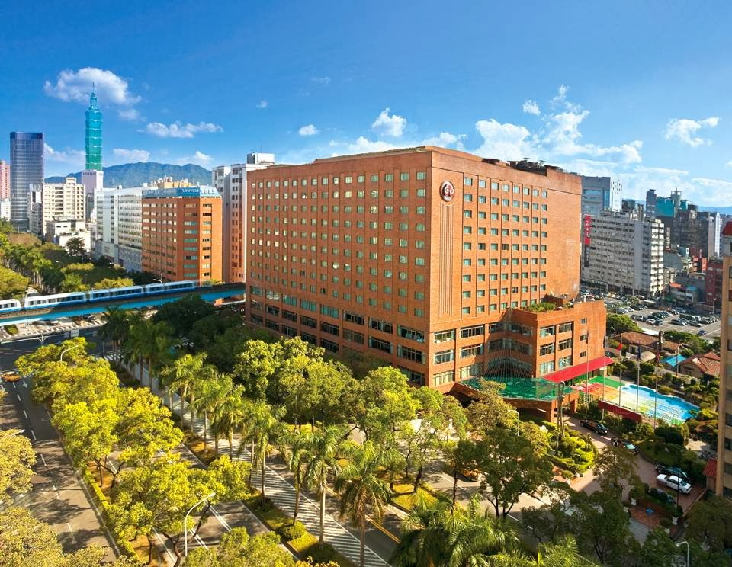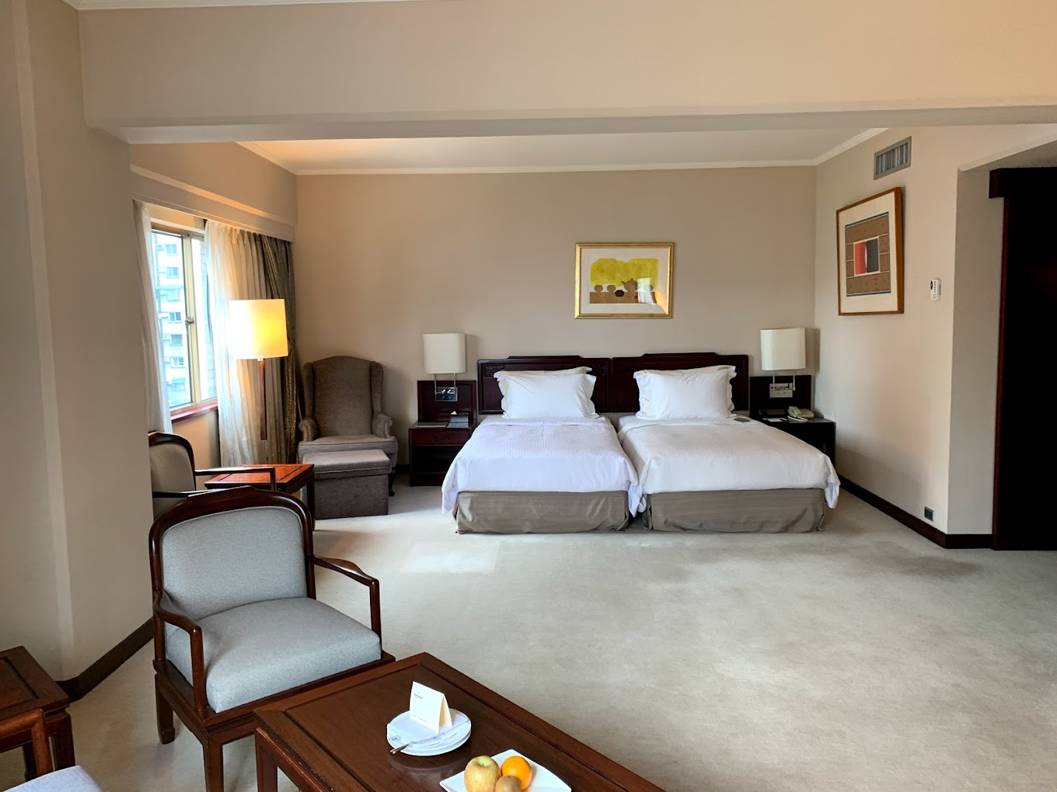**

# (10 Minute by shuttle to the venue)

# The Howard Hotels

* Single Room price: USD230.00 per room
* Number of rooms: 20
* Double/Twin Room price: USD300.00 per room
* Number of rooms: 80
* Board plan: full board
* Check-in from 24 September 2024 – 15:00
* Late check-out 04 October 2024 – 11:00

Hotel website: https://www.howard-hotels.com.tw/

# TRANSPORTATION

Transportation will be provided from Taoyuan airport / Taipei Song-Shan airport to the official hotel, from two days before the official practice day and until two days after the closing day for 40 USD/per person. Local transport will be available between the official hotel, practice and competition venues for free. Transport timetables will be confirmed.

# VISA

All participants who need an entry visa to Taipei, will be required to complete the **Visa Support sections** in WAREOS by no later than **27** th **July 2024.**

It is the applicants’ responsibility for supplying the necessary information, ensuring all details are up to date, correct and submitted by the deadlines specified.

In addition, all participants that require a visa are kindly requested to supply a copy of their latest/valid passport. Copies of each application can be uploaded on WAREOS. All passport copies and personal details entered/uploaded to WAREOS will be held securely and in the strictest of confidence and not shared with other parties.

# PAYMENT CONDITIONS

Complete all necessary sections in WAREOS and make full payment by the specified deadlines. Bank transfers only, no credit cards will be accepted. All bank charges will be paid by the participants.

The entry fees should be paid in full before arrival.

To confirm hotels reservations, a minimum 50% deposit of the total amount is required to be bank transferred to the OC before **27 June 2024**. Reservations after this date will be considered only according to availability. The final outstanding balance shall be made via bank transfer before arrival. Accommodation cannot be guaranteed after this deadline. A balanced invoice will be provided via WAREOS.

# BANK INFORMATION FOR ACCOMMODATION, TRANSPORTATION AND ENTRY FEES

A/C Name: Chinese Taipei Archery Association Federation’s Address: R701, No.20, Chu-Lun St., Taipei, Taiwan. Telephone number: +886-2-2721-6182

Bank: TAIWAN SHIN KONG COMMERCIAL BANK

Account Number: 0143118886868

Swift: MKTBTWTP523

Bank’s address: No. 36, Songren Road, Xinyi District, Taipei, Taiwan.

Bank’s Phone: +886-2-8758-7288

**NOTE**: ALL PAYMENTS SHALL BE MADE IN USD.

# CANCELLATIONS & CHANGES

All cancellations and changes must be made through WAREOS:

* Should flight arrival details change last minute, please contact the Organising Committee using the details indicated in the team managers’ booklet.
* If a participant’s arrival is later than the original scheduled arrival date, the room will be charged from the date of the original booking in WAREOS.
* An email will automatically notify the Organising Committee and Member Association of any changes made in WAREOS.

# ADDITIONAL INFORMATION TRAINING

A training field will be available starting on **26 September 2024** at the Tipei Stadium located approximately 15 to 30 minutes from the official hotels.

# WEATHER

Temperatures in March are expected to range between 25 and 30 degrees Celsius. The average in the last few years has been 28 degrees Celsius.

# MEDIA REGISTRATION

Media representatives can apply by emailing at [ctaaint@gmail.com](mailto:ctaaint@gmail.com) (LOC media contact)

# INTERNET

Will be available in the official hotels for free (in hotel rooms and in the lobby). There will also be Wi- Fi available for access to results on venue.

# WATER

Each participant with receive clean bottles of water.

Bottled water will be available at the qualification and practice venues.

# LOC CONTACT

Name: Tzu-Yun LIN

Address: R701, No.20, Chu-Lun St., Taipei, Taiwan

Email: [ctaaint@gmail.com](mailto:ctaaint@gmail.com)

Language: Chinese and English

Phone number with international extension: +886-2-2721-6182

Looking forward to welcoming you in Taipei, Chinese Taipei.