TO ALL World Archery Member Associations

Dear President,

As Chair of the Local Organising Committee (LOC) of the second stage of the Hyundai Archery World Cup to be held in Yecheon – Korea on 21-26 May 2024, I would like to invite and welcome you all to our events.

Yecheon is renowned as the home of bows. The history of making traditional Korean bows and arrows goes back to the ancient times in Yecheon which holds the intangible cultural property of bow and arrow making technology. Yecheon hosts bow-themed festivals every year. Yecheon has produced four Olympic gold medalists. Yongho Jang, Soonyeong Kim, Okhee Yoon, and Jaeduk Kim took six of the 27 gold medals South Korea won in archery at the Olympics.

Being recognized for its successful hosting of the archery events at the 2003 Daegu Summer Universiade and at the 2015 Mungyeong Military World Games, and the 2023 Yecheon Asian U20 Athletics Championships, Yecheon was selected to host the second stage of the 2024 Hyundai Archery World Cup, taking a leap forward as an international sports city.

Yecheon Jinho International Archery Field, the venue for the competition, was established in 1995, named after Jinho Kim, who won five gold medals at the 30th World Archery Championships in Berlin in 1979 as an 18-year-old senior at Yecheon Girls' High School. Jinho International Archery Field is equipped with the best facilities, blessed with beautiful scenery.

We are committed to making every effort to closely work with the World Archery Federation and the Korea Archery Association to ensure that Korea and Yecheon provide a wonderful and unique experience for the participants at the Archery World Cup to be first held in Yecheon, and that the athletes perform to the best of their abilities ahead of the Paris Olympics.

We look forward to welcoming you under the bright sunshine of beautifully blooming spring days in Yecheon, Korea,

Sincerely yours,

Hagdong Kim
Chairman of LOC

Important Dates:

Please find enclosed detailed information regarding this event. To register participation, please complete all the necessary sections in WAREOS (https://extranet.worldarchery.sport) within the deadlines listed below.

Summary of deadlines:

Registration Opening date on WAREOS | 17 January 2024
Preliminary Entries / 50% down-payment | 21 February 2024
Final Entries / Full invoice payment | 30 April 2024
Transportation | 30 April 2024
Visa support | 19 April 2024
Full refund cancellation deadline  *After this deadline, the LOC is allowed to retain all amounts due by the Member Association. | 30 April 2024

Please adhere to the provided deadlines. It is imperative for Member Associations to update WAREOS with any changes, including cancellations or modifications, even after submitting a preliminary entry. Non-compliance may result in additional penalties.

PRELIMINARY PROGRAMME

19 May 2024  Sunday | Arrival of participants  Practice field and local transport available
20 May 2024  Monday | Arrival of participants  Practice field and local transport available
21 May 2024  Tuesday | Official Practice & Qualification Round  Official Practice  Compound 50m Round
22 May 2024  Wednesday | Team Eliminations & Qualification  Compound Team Matches & Recurve Qualifications
23 May 2024  Thursday | Individual Eliminations  Team Eliminations  (Recurve Team Matches and Compound Individual Matches)
24 May 2024  Friday | Mixed Team Eliminations & Individual Eliminations  (Mixed Team Matches and Recurve Individual Matches)
25 May 2024  Saturday | Finals – Compound
26 May 2024  Sunday | Finals – Recurve

NOTE: This preliminary programme is subject to change according to participation and TV requirements. All changes will be published and distributed in good time.
PRELIMINARY & FINAL REGISTRATION
All entries, accommodation reservations, transport needs, flight arrival/departure information and visa invitation letter requests are to be completed using the World Archery Registration Online System WAREOS https://extranet.worldarchery.sport. This system handles the entire registration process for this event. No entry forms, hotel reservations or transportation forms will be accepted; all information must be entered into WAREOS.

Member associations can login to WAREOS at https://extranet.worldarchery.sport with the username and password assigned by World Archery. After entering WAREOS, selecting the event from the list will allow a member association to register their athletes. Select/press the “Entries” button to see the list of categories in the event. Select/press the “category” to enter the athlete and official numbers/details participating for that event. A WAREOS User Manual can be downloaded in PDF format (English) upon login.

Contact wareos@archery.sport with any questions regarding technical problems on WAREOS. For any question regarding the organisation of the event (transport, accommodation, meals, invoices, visa etc.) please directly contact the LOC.

A maximum number of 4 athletes per country can be registered into each category of the event. Preliminary entries should be completed using WAREOS.

Member Associations can only use WAREOS to make any changes, amendments or cancellations to entries and will be able to do so at any time. An email will automatically notify the Organising Committee and Member Association of any changes made in WAREOS.

ACCREDITATION FEES
Individual 595 USD
Team Manager 215 USD
Coach 297 USD
Medical 215 USD
Guest 595 USD
VIP Guest 892 USD

All other fees applicable to the event can be found in the Policies and Procedures Athletes, Officials and Team Management.

Member Associations that have penalty fees outstanding from 2023 will need to have paid these penalty fees before being eligible to enter and compete.

Any entries received less than 3 days before the team managers meeting for a Hyundai Archery World Cup or World Championships will be refused if no preliminary entry and/or final entry are made prior. This decision cannot be appealed by the teams and is fully compliant with the current World Archery rules, article 3.7.1.2.

Entries received after the deadlines, are subject to penalties as clearly stated in the rule book and the invitation documents of World Cups and World Championships. A Member Association that has made final entries in WAREOS and does not participate will be invoiced for the number of entries entered in the system, unless they have informed World Archery and the Organising Committee in writing at least one week prior to the event that they are unable to attend.

ACCOMMODATION
Andong Grand Hotel – Three Star Hotel
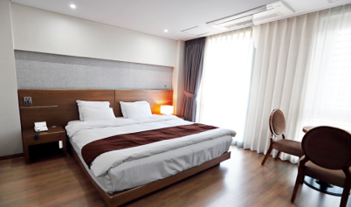
- Double/Twin Room:
Type | Price | Number of rooms | Room size | Bed type
Type A | USD 155.00 | 30 | 27 m² | 2 single (100*200cm) beds
Type B | USD 178.00 | 8 | 41 m² | 2 double (140*200cm) beds
- Triple Room Price: USD 235.00 per room
- Number of rooms: 5
- Board plan: full board (lunch will be served at the Venue)
- Check-in from 19.05.2024, 15:00
- Check-out 27.05.2024, 11:00
- Hotel>Venues (distance/time min): 41km/35min
- Hotel website: http://www.andonggrandhotel.com

Andong Richell Hotel - Two Star Hotel
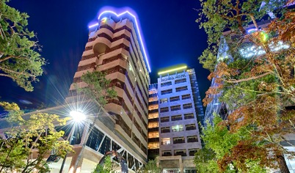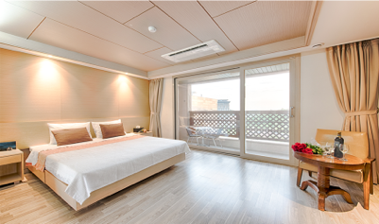
- Single Room
Type | Price | Number of rooms | Room size | Bed type
Type A | USD 125.00 | 17 | 27 m² | 1 double (150*200cm) bed
Type B | USD 163.00 | 20 | 43 m² | 1 double (150*200cm) bed
- Double/Twin Room
Type | Price | Number of rooms | Room size | Bed type
Type A | USD 170.00 | 17 | 27 m² | 2 single (100*200cm) beds
Type B | USD 208.00 | 21 | 43 m² | 2 single (100*200cm) beds
- Board plan: full board (lunch will be served at the Venue)
- Check-in from 19.05.2024, 15:00
- Check-out 27.05.2024, 11:00
- Hotel>Venues(distance/time min): 41km/35min
- Hotel website: http://www.richell-andong.co.kr

Yeongju SPA Tourist Hotel - Two Star Hotel
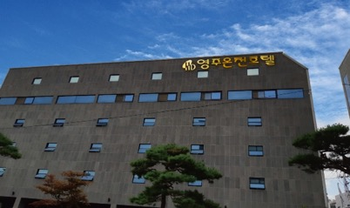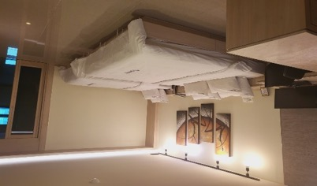
- Single Room Price: USD 109.00 per room
- Number of rooms: 30
- Double/Twin Room price: USD 216.00 per room
- Number of rooms: 13
- Board plan: full board (lunch will be served at the Venue)
- Check-in from 19.05.2024, 16:00
- Check-out 27.05.2024, 11:00
- Hotel>Venues (distance/time min): 27km/25min
- Hotel website: http://www.yeongjutouristhotel.co.kr

JS Boutique Hotel

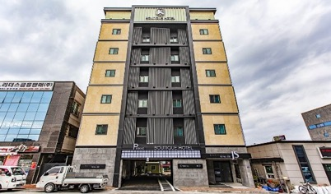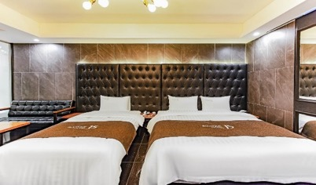

- Single Room Price: USD 106.00 per room
- Number of rooms: 30
- Double/Twin Room price: USD 178.00 per room
- Number of rooms: 5
- Board plan: full board (lunch will be served at the Venue,
- Check-in from 19.05.2024, 17:00
- Check-out 27.05.2024, 12:00
- Hotel>Venues (distance/time min): 27km/25min

C.M Park Hotel – Three Star Hotel
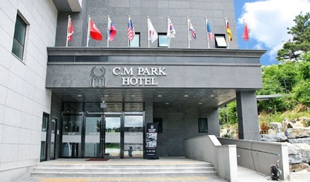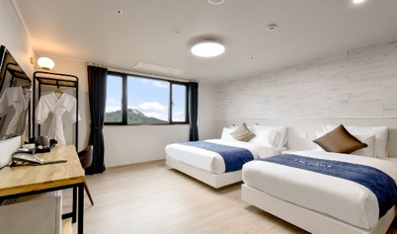

- Double/Twin Room
Type | Price | Number of rooms | Room size | Bed type
Type A | USD 175.00 | 7 | 30 m² | 2 single (100*200cm) beds
Type B | USD 213.00 | 8 | 36 m² | 2 double (140*200cm) beds
- Triple Room Price: USD 287.00 per room
- Number of rooms: 7
- Board plan: full board (lunch will be served at the Venue)
- Check-in from 19.05.2024, 15:00
- Check-out 27.05.2024, 11:00
- Hotel>Venues (distance/time min): 15km/15min
- Hotel website: http://www.cmparkhotel.com/

Queen Motel

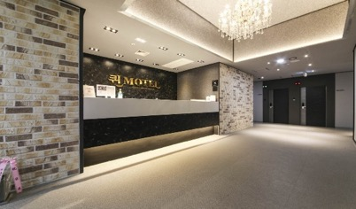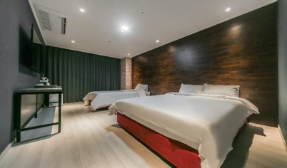

- Single Room Price: USD 81.00 per room
- Number of rooms: 37
- Double/Twin Room price: USD 148.00 per room
- Number of rooms: 24
- Board plan: full board (lunch will be served at the Venue)
- Check-in from 19.05.2024, 15:00
- Check-out 27.05.2024, 11:00
- Hotel>Venues (distance/time min): 15km/15min

Sono Moon Danyang



- Single Room Price: USD 123.00 per room
- Number of rooms: 145
- Double/Twin Room price: USD 190.00 per room
- Number of rooms: 61
- Board plan: full board (lunch will be served at the Venue)
- Check-in from 19.05.2024, 15:00
- Check-out 27.05.2024, 11:00
- Hotel>Venues(distance/time min): 61km/50min
- Hotel website: http://www.sonohotelsresorts.com/dy

Rooms are allocated on a first come, first serve basis. Accommodation includes breakfast and dinner non-alcoholic drinks. Lunch will always be served at the archery venue; dinner will be served at the hotel.
The LOC will not be responsible to provide any event information at non-official events nor provide transportation to the venues.

TRANSPORTATION
Transportation will be provided from Incheon airport to the official hotel, from two days before the official practice day and until one days after the closing day at 50 USD price for one way. Local transport will be available between the official hotel, practice, and competition venues for free. Transport timetables will be confirmed.

VISA
All participants who need an entry visa to Country, will be required to complete the Visa Support sections in WAREOS by no later than 19 April 2024.

It is the applicants’ responsibility for supplying the necessary information, ensuring all details are up to date, correct and submitted by the deadlines specified.

In addition, all participants that require a visa are kindly requested to supply a copy of their latest/valid passport. Copies of each application can be uploaded on WAREOS. All passport copies and personal details entered/uploaded to WAREOS will be held securely and in the strictest of confidence and not shared with other parties.

BANK INFORMATION FOR ACCOMMODATION, TRANSPORTATION AND ENTRY FEES
A/C Name: YECHEON 2024 HYUNDAI ARCHERY WC LOC
Federation’s Address: 38, Yanggungjang-gil , Yecheon-eup, Yecheon-gun, Gyeongsangbuk-do
Telephone number: +82-54-650-8225
City and Country: Yecheon, Republic of Korea
Bank: NONGHYUP BANK
Account Number: 452-0028-1789-61
Swift: NACFKRSEXXX
Bank’s address: 75, Hyoja-ro , Yecheon-eup, Yecheon-gun, Gyeongsangbuk-do
Bank’s Phone: +82-54-655-3107
City: Yecheon, Republic of Korea

NOTE: ALL PAYMENTS SHALL BE MADE IN USD.

CANCELLATIONS & CHANGES
All cancellations and changes must be made through WAREOS:

- Should flight arrival details change last minute, please contact the Organising Committee using the details indicated in the team managers’ booklet.
- If a participant’s arrival is later than the original scheduled arrival date, the room will be charged from the date of the original booking in WAREOS.
- An email will automatically notify the Organising Committee and Member Association of any changes made in WAREOS.

HEALTH REGULATIONS

Medical emergency contact and location
KWON Hospital, 136, Sijang-ro, Yecheon-eup, Yecheon-gun, Gyeongsangbuk-do
Gyuho Kwon. +82-54-654-6611

ADDITIONAL INFORMATION

Training
A training field will be available starting on 19 May 2024 at the Jinho International Archery Field.

Weather
Temperatures in May are expected to range between 13 and 24 degrees Celsius. The average in the last few years has been 18 degrees Celsius.

Media Registration
Media representatives can apply for emailing happyme0@korea.kr (LOC media contact).

Internet
Will be available in the official hotels for free (in hotel rooms and in the lobby). There will also be Wi-Fi available for access to results on venue.

Water
Each participant with receive clean bottles of water.
Bottled water will be available at the qualification and practice venues.

LOC CONTACT

Name: Hye-jin Oh
Address: 38, Yanggungjang-gil , Yecheon-eup, Yecheon-gun, Gyeongsangbuk-do
Email: happyme0@korea.kr
Language: English
Phone number with international extension:

Looking forward to welcoming you in Yecheon, Republic of Korea

Terms and Conditions
Introduction
The Member Association acknowledges to have understood and accepted in their whole and without any restrictions the sale and purchase terms and conditions of this invitation package, and of the registration platform https://extranet.worldarchery.sport/wareos/.

Consequently, the Member Association who wishes to register to an event, and book some or all associated extras proposed by the local organizing committee acknowledges that they are fully aware present terms and conditions are accepted by entering information in WAREOS.
Any Member Association declares that it is entitled to enter a contractual relationship with the Local Organising Committee of the event, in accordance with these terms and conditions.
The Local Organising Committee commits itself to communicate, within reason, to its potential clients the greatest information available on the following topics:
Description of the main characteristics of the proposed products and of their use.
Pricing
Information on the methods of payment and reimbursement conditions.

Article 1: Entirety
The platform https://extranet.worldarchery.sport/wareos/ is the propriety of, has been designed and created and is managed by World Archery Federation at Lausanne, Switzerland, and put at the disposal of the Local Organising Committee to facilitate registration to World Archery events.
The present terms and conditions include any and all rights and obligations of the parties. No single, specific, or general term or condition that may appear on documentation sent, given, or handed over to a Member Association will alter, replace, or complete parts of or the entirety of these terms and conditions
World Archery reserves the right to modify at any time and without any preliminary notification of any kind these terms and conditions.

Article 2: Object
The present terms and conditions define the rights and obligations of the parties in relation to the registration made through the platform https://extranet.worldarchery.sport/wareos/ of services offered by the Local Organising Committee in the scope of the event it has been set for.

Article 3: Contractual documents
The present terms and conditions and the registration process make up the contractual documents between the parties.

Article 4: Electronic signature:
The Member Association’s entering registration information is the electronic signature which is binding between the parties in the same sense as a handwritten signature would be.

Article 5: Registration Confirmation – Contract
The contract is validated as soon as the Member Association has entered its preliminary registration by entering information in WAREOS. A modification of the registration is possible until the deadline for registration set in the document. Modifications may be subject to penalty fees.

Article 6: Prices
The official prices are listed in the “Policies and Procedures Athletes, officials and team management”, the invitation package prices will be based on the official price list, converted to the currency elected by the LOC for invoicing (CHF, EUR, or USD).
The official prices valid on the date that the registration confirmation is sent to the Member Association are binding between the parties.
Article 7: Payment methods
All payments shall be made by bank transfer to the organising committee respecting the stated deadlines, with all bank charges paid by the Member Association. For any open invoices that are not settled 21 days prior the beginning of the event, the Local Organising committee will be entitled to charge a 5% surcharge on all open amounts.
Any payments received cash by World Archery on behalf of the organising committee will incur a 10% additional service fee, to be paid to World Archery.

Article 8: Payment deadlines and refunds
After the final deadlines of registration mentioned in this document, Member Association will not be entitled to any refund, and all remaining unpaid amounts shall be paid to the Local Organising Committee.
Failure to do so, will results in an immediate suspension of the Member Association, who will be set as not in good standing on the day of the official practice of the event, and so until the full amount is paid to the LOC.

Article 9: Availability of services
The availability of services is guaranteed on a first come, first serve basis, provided that the payment of such service has been paid to the local organising committee, partially or in full as mentioned in this document.
The local organising committee is not required to hold services for a Member Association that as not paid in full such service.

Article 10: Force-majeure
None of the two parties will have failed in their respective contractual obligations if their execution is delayed or prevented by a case of force-majeure. Cases considered to be a force majeure are extraordinary events or circumstances beyond the control of the parties, such as a war, strike, riot, crime, or an event described by the legal term "act of God" (e.g., flooding, earthquake, volcano eruption, etc). However, force majeure is not intended to excuse negligence or other malfeasance of a party, as where non-performance is caused by the usual and natural consequences of external forces, or where the intervening circumstances are specifically contemplated. The party experiencing a force majeure must notify in writing with 24 hours after becoming aware of the occurrence. The parties will then, within 7 business days examine, unless the force majeure prevents it, if and how the contractual obligations will be met.

Article 11: Privacy statement
All information exchanged by the Parties will be treated with the utmost confidentiality
All information requested by World Archery and the Organising Committee from the Member Association are necessary to process the event registration and can therefore be communicated only to the contractual partners of World Archery and the Local Organising Committee.
World Archery and the Local Organising committee are authorized to send informative and promotional e-mails to the Member Association, using the WAREOS e-mail address and the contact person provided by the Member Association during the registration.
October 2023 by World Archery Federation, Maison du Sport International, Avenue de Rhodanie 54 - 1007 Lausanne (Switzerland)

