TO ALL World Archery MEMBER ASSOCIATIONS

Dear President,

On behalf of the Organizing Committee (OC) of the World Archery Championships 2015, Copenhagen – Denmark and World Archery Denmark, we would like to invite your country to the World Archery Championships 2015, which will be held from 26th of July to the 2nd of August in Copenhagen, the capital of Denmark.

To register participation, please find enclosed the necessary documents and return your completed forms within the deadlines listed below:

Summary of deadlines:

- Hotel Reservation Form & Deposit 12 April 2015
- Preliminary Entries 28 April 2015
- Visa Support Form 26 May 2015
- Final Hotel Reservation Form 1 June 2015
& Remaining Payment
- Transportation Form 22 June 2015
- Final Entries and entry payment 5 July 2015

We will also be hosting the World Archery Congress, prior to the Championships, 24^{tt} - 25th July. AC Bella Sky Copenhagen will be the Congress hotel. A separate invitation package will be sent out for Member Associations to register their attendance.

Note that accreditation for Congress does not give access to the finals of the Championship, 1st and 2nd of August. For ticket information see page 8.

We are looking forward to welcoming you and your teams, to Copenhagen – Denmark.

Sincerely yours,

Rolf Lind
President
World Archery Denmark
Mads Bang Aaen
Event Director World Archery Championships 2015

mba@archery2015.com

PRELIMINARY PROGRAMME
NOTE: This is a preliminary programme and subject to change according to the number of participants in each division and TV requirements. All changes will be published and distributed to all participants in advance.
PRELIMINARY & FINAL REGISTRATION
All registration process must be completed using the World Archery Online Registration System (WAREOS, formerly FORS): http://register.worldarchery.org. No entry forms will be accepted for registering to this event.

A maximum number of 3 athletes per country (host country included) are allowed to be registered into each category of the event. Preliminary entries have to be completed using the WAREOS.

In order to use WAREOS, please login on http://register.worldarchery.org with your Username and Password assigned by World Archery. After entering the WAREOS, please go to "Online Registration" and register your athletes for this event. A "WAREOS User Manual" can be downloaded in PDF format (English) using the same website link.

For any questions regarding the WAREOS, please contact the World Archery office, Ms Raheleh AHADPOUR (rahadpour@archery.org).

Start date for online registration using WAREOS 30 January 2015
End of Preliminary registration using WAREOS: 28 April 2015
End of Final registration using WAREOS: 5 July 2015

Please pay attention to the stated deadlines. Teams will not be able to enter or update their data in WAREOS, after the deadlines, as the system will be blocked. If, teams wish to make any changes to their Final Registration, after the deadline, you need to contact Ms Raheleh AHADPOUR, World Archery Member Services Coordinator (rahadpour@archery.org).

Final Entries processed after the deadline will result in a penalty fee of 50 Euros per athlete to be paid to the LOC upon arrival at the field.

Final registrations that differ by more than 4 athletes from the preliminary registration or have been submitted after the preliminary deadline will result in a penalty fee of 150 Euros to be paid to the LOC upon arrival at the field.

Any entries received less than 3 days before the team managers meeting for a World Championships will be refused if no preliminary entry and/or final entry were made prior. This decision cannot be appealed by the teams and is fully compliant with the current World Archery rules, article 3.7.1.2. Entries received after the deadlines, are subject to penalties as clearly stated in the rule book and the invitation documents of World Cups and World Championships. A Member Association that has made final entries in WAREOS and does not participate will be invoiced for the number of entries entered in the system.

Member Associations that have penalty fees outstanding from 2014 will need to have paid these penalty fees before being eligible to enter and compete.

ACCOMMODATION & GENERAL INFORMATION
Teams who do not reserve their accommodation through the LOC will be charged a double entry fee. 300 euro (athletes) / 200 euro (officials)

- Hotel reservations should be made before: 12 April 2015
- Final Hotel Reservation 1 June 2015
- Transportation Forms: 22 June 2015

To confirm your hotel reservations, a 60% deposit, of the total amount, is required to be transferred, to the LOC before 12 April 2015, via a bank transfer, using the details provided on page 18. Reservations received after these dates will be considered according to availability.

IMPORTANT!
Please note that there will be a limited number of rooms at each hotel. To ensure that you stay at your preferred hotel, please send the Hotel reservation form ASAP. Note, that the reservation is final only after the OC have received 60% deposit. We will use the principle of first come first served. Also note that it will not be possible to refund the deposit after the 12 April.

There are two official hotels:
1. AC Bella Sky Copenhagen (4 Star)
Single room 200 Euro
Double room 260 Euro

2. Scandic Sydhavn ( 4 Star)
Single room 155 Euro
Double room 215 Euro
Triple room 290 Euro
Suite/triple room 350 Euro

The hotel room rates are per room, per night, including free internet, full board (breakfast, lunch and dinner) at the hotels. Meals include water, lemonade, tea and coffee. Additional purchases in the hotel bar, café and minibar is at own expense.
Please refer to the accommodation pages below for detailed hotel information.

AC Hotel Bella Sky Copenhagen (Official hotel of the World Archery Congress) http://acbellaskycopenhagen.dk/
At the international 4-star designer hotel, AC Hotel Bella Sky Copenhagen, you will experience Scandinavian quality, comfort and service in exclusive surroundings. Bella Sky opened in 2011 as Scandinavia’s largest hotel with 23 floors, 812 rooms, three restaurants, two bars and an aqua spa & fitness. The hotel has a unique architecture and design profile and all of the spacious, elegant rooms are furnished with original design furniture, floor to ceiling windows and free Wi-Fi. You can relax in the pools in our aqua spa, taste the Nordic classic cuisine in our restaurants and enjoy the amazing panoramic view of the Copenhagen skyline in our Sky Bar. Bella Sky also has its own metro station from where you can reach Copenhagen city centre in less than 10 minutes.
The costs of parking at Bella Sky is 80 DKK per day

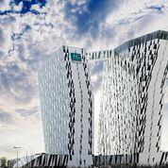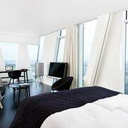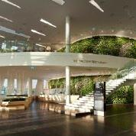
Scandic Sydhavn http://www.scandichotels.dk/Hotels/Danmark/Kobenhavn/Scandic-Sydhavnen/

The modern Scandic Sydhavnen hotel is located 3 km from central Copenhagen, only 10 minutes from Copenhagen Airport and 3 minutes from Sydhavn Station.

Hotel Scandic Sydhavnen is situated within easy reach of Copenhagen's shopping opportunities and popular attractions, such as Tivoli Amusement park, Amalienborg Palace and the shopping mall Fisketorvet. Close to the hotel, you will find Vesterbro district, an area full of trendy shops and restaurants. Copenhagen Airport is only 10 minutes from the hotel by car.

Facility at hotel Scandic Sydhavnen we offer great facilities for both business and leisure guests. You can stop by our hotel restaurant and bar for great food and drink or visit the modern gym. Arrange conferences or events for up to 400 delegates in our brand new meeting and conference venues with high tech facilities. We also offer wireless internet access at no extra charge throughout the hotel. At Hotel Scandic Sydhavnen parking is free for cars, minibuses and buses. For free parking, you need to get a voucher at the reception on arrival.
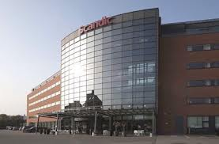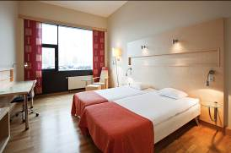
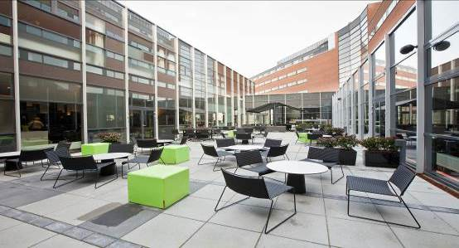
Important Note:
Please complete all the necessary forms by the deadlines given and arrange full payment for accommodation before 1 June 2015. No credit cards or travel checks will be accepted on site.

All participants should book their accommodation through the LOC. Participants that do not book their accommodation through the LOC, will have to pay double entry fees and will not be entitled to any event information or transportation.

Teams will also need to register for their accreditation, at the latest, the day before official practice. If participants do not register the day before, no changes will be made to the entry list. Participants will not be allowed to compete if registration is not completed in time and will not be allocated to a target.

Overview over the most important places in Copenhagen.
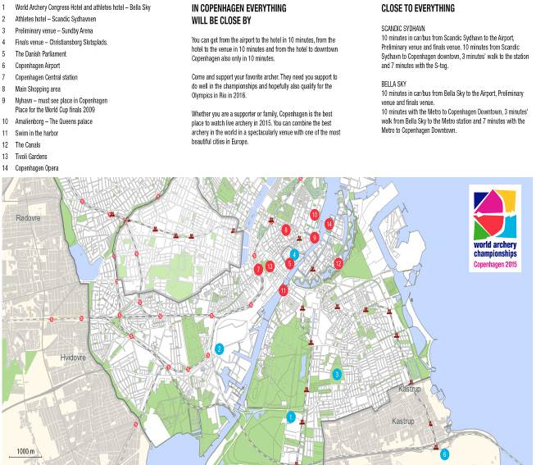

Fans and Spectators in Copenhagen
The capital of Denmark will set a spectacular scene of yet another big sporting event this summer when the world’s best archers come to Copenhagen.
The 1 and 2 of August will be the finals of the World Archery Championships, hosted in the historic surroundings, in front of the Danish Parliament at Christiansborg Slotsplads.
Finals are divided into a two sessions, morning and afternoon both days. Exact times and programme are to be confirmed.
Compound Finals take place Saturday 1 August and the Recurve Finals taking place the following day, Sunday 2 August at the same venue.
Tickets cost 10 euro per session + service charges. A weekend pass costs 30 euro + service charges.
There will be free entrance at the finals for team managers and athletes, but congress delegates will have to buy a ticket, if they decide to attend the finals.
The preliminary rounds will be staged at Sundby Idrætspark, not far from the city centre, 26 - 31 July. Entrance is free of charge. The preliminary rounds are the first opportunity to qualify places for their National Federation at the Rio 2016 Olympic Games.

PRELIMINARY HOTEL RESERVATION FORM

Team Manager Details:

Sex : Women Men

Name of Member Association: _________________________________________

Country / Region: _____________________

Contact Name: ________________________________

Telephone: __________________ E-mail: _____________________

Country/Team from: ___________________________________________

Hotel: ____________________________________

From the __________ to the __________

Number of Rooms:

Single (Bella sky: 200 Euro – Scandic: 155 Euro)

Double (Bella Sky: 260 Euro – Scandic 215 Euro)
Triple:(Only for Scandic Sydhavn 290 Euro)
Suite/triple:(Only for Scandic Sydhavn 350 Euro)

Do you require a room for a disabled team member? Yes No

If yes, please specify: ______________________________________________

Do any of your team members have dietary requirements or allergies such as, vegetarian, nut allergies or gluten free etc. Yes No

If yes, please specify: ______________________________________________

Accommodation Payment:

ROOM TYPE AMOUNT OF ROOMS NIGHT RATE P/N TOTAL RATE

___________ _____________________ _________________ _____________

Single __________________ x ___________ x = _______________

Twin __________________ x ___________ x = _______________

Triple __________________ x ___________ x = _______________
Suite/

Triple__________________ x ___________ x = _______________

TOTAL ACCOMMODATION AMOUNT _____________________________

DEPOSIT 60% OF TOTAL AMOUNT ______________________________

Please pay the deposit before 12 April 2015

Date: ______________________

Signature of President / Secretary General: ______________________________

PLEASE RETURN THIS HOTEL RESERVATION FORM TO LOC BEFORE
12 April 2015 by email to hotels@archery2015.com

ENTRY FEE

Entry fee:
Individual: 150 Euro per athlete
Officials: 100 Euro per person

Entry fee in NON official hotels:
Individual: 300 Euro per athlete
Officials: 200 Euro per person

There is no entry fee for teams.

For participants using official hotels, entry fees include daily local transport to and from the practice field to official hotels during the qualification, elimination and finals venues (timetable to be confirmed). All participants should book their accommodation through the LOC.

Participants that do not book their accommodation through the LOC, will have to pay double entry fees and will not be entitled to any event information or transportation.

TRANSPORTATION FORM

AIRPORT (Arrival) – HOTEL – AIRPORT (Departure)

Country/Team from: ___________________________________________

Number of passengers: ___________ person/s

Arrival information

We will arrive by plane in Copenhagen Airport:

From: ___________________________ Flight Nr: ______________________

Date: _____________________ (DD/MM/YY) Arrival Time: ________________

Departure information

We will depart by plane from Copenhagen:

To airport: _________________________ Flight Nr: _______________

Date: ____________________ (DD/MM/YY) Departure Time: _______________

If you are not arriving or departing in one group, please specify in the tables below.

Arrivals:

No. of persons | Arriving from | Flight no. | Date | Time

Departures:

No. of persons | Arriving from | Flight no. | Date | Time

Date: ____________________ (DD/MM/YY)

Signature: ______________________________

President / Secretary General MA: _______________________________

Note:
The entry fee INCLUDES transportation between hotels and archery venues.

For transportation from other airports please contact LOC for fee quotation.

PLEASE RETURN THIS TRANSPORTATION FORM TO THE LOC ASAP, BUT BEFORE 22 JUNE by email to: hotels@archery2015.com.

Airport Transportation payment: (Round trip)

NUMBER OF PERSONS FEE (EUR) TOTAL (EUR)

______________________ x Euro 15 = __________________________

Please pay the transportation fee before 22 June

FINAL HOTEL RESERVATION

Personal information team manager:

Sex : Women Men

Name of Member Association: _________________________________________

Country / Region: _____________________

Contact Name: ________________________________

Telephone: __________________ E-mail: _____________________

Country/Team from: ___________________________________________

Hotel: ____________________________________

From the __________ to the __________

Number of Rooms:

Single (Bella sky: 200 Euro – Scandic: 155 Euro)

Double (Bella Sky: 260 Euro – Scandic 215 Euro)
Triple:(Only for Scandic Sydhavn 290 Euro)
Suite/triple:(Only for Scandic Sydhavn 350 Euro)

Do you require a room for a disabled team member? Yes No

If yes, please specify: ______________________________________________

Do any of your team members have dietary requirements or allergies such as, vegetarian, nut allergies or gluten free etc. Yes No

If yes, please specify: ______________________________________________

Date: ______________________

Signature of President / Secretary General: ______________________________

Accommodation Payment:

ROOM TYPE AMOUNT OF ROOMS NIGHT RATE P/N TOTAL RATE

___________ _____________________ _________________ _____________

Single __________________ x ___________ x = _______________

Twin __________________ x ___________ x = _______________

Triple __________________ x ___________ x = _______________

Suite/
Triple__________________ x ___________ x = _______________

TOTAL ACCOMMODATION AMOUNT _____________________________

REMAINING
PAYMENT 40% OF TOTAL AMOUNT ______________________________

To Guarantee Reservations:
For the payment of accommodation, a 60% deposit of the total amount payable is required to be paid by 12 April 2015. The remaining payment for accommodation should be paid with the final hotel reservation by 1 June 2015. Accommodation cannot be guaranteed after this deadline.

A balance invoice will be provided via email or on arrival, as required, after payment.

It will not be possible after 12 April to have the deposit refunded.

PLEASE RETURN THIS FINAL HOTEL RESERVATION FORM TO LOC BEFORE
1 June 2015 by email to hotels@archery2015.com

FINAL ENTRY FEE FORM
Entry Fee Payment:
The entry fees should be paid in full BEFORE 5 July.

NUMBER OF PERSONS ENTRY FEE (EUR) TOTAL (EUR)

Athletes ___________________ x Euro 150 = ________________________

Officials ___________________ x Euro 100 = ________________________

TOTAL ENTRY FEE ________________________

Please send this form to the LOC BEFORE 5 July 2015 by email to hotels@archery2015.com

PAYMENT CONDITIONS:
For the payment of accommodation, a 60% deposit of the total amount payable is required to be paid with preliminary Hotel registration by 12 April 2015. The remaining payment for accommodation should be paid with the final hotel registration by 1 June 2015. Accommodation cannot be guaranteed after this deadline.

A balanced invoice will be provided via email after final payment. There is only one account number where payments are to be made. Please be aware that accommodation, transportation and entry fee must be paid in to this bank account number written below:

BANK INFORMATION for ACCOMMODATION, TRANSPORTATION AND ENTRY FEE:

VAT/CVR Number of World Archery Denmark: 892 62 712

Bank information:
Bank Name: Nordea
Bank address: Hovedvejen 112, 2600, Glostrup, Denmark
IBAN: DK0920004386654315
Swift/BIC: NDEADKKKXXX

NOTE: Please indicate in the reference/notes section the team or reservation name that corresponds to the payment.

ALL PAYMENTS SHALL BE MADE IN EURO
By BANK TRANSFER

All bank charges/fees are the responsibilities of the sender.
CREDIT CARDS or TRAVEL CHECKS will not be accepted.

ADDITIONAL INFORMATION ABOUT COPENHAGEN

Copenhagen is the capital of Denmark, and has around 1 million citizens. Copenhagen is well known for its many beautiful places, some of the best restaurants in the world, as a city where more than 50% of the citizens regularly use a bike to get around, and where the water in the harbour is so clean – that you can swim in it.
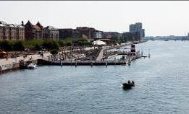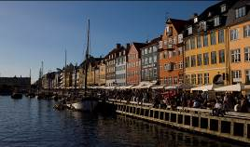

Copenhagen is a pocket-sized fairy tale and at the same time, a buzzing and innovative hub of ideas. Copenhagen is a city large enough for every kind of life philosophy, but small enough to bicycle from one end to the other in twenty minutes. It is all there, the urban pulse in the cobbled streets, the castles and bell towers, the artists, makers and the green grass, the mothers, babies and their strollers, the hipsters and their dreams, the prince and the queen.

There are several tourist attractions in Copenhagen. Among the most popular are Tivoli, the Amusement park in the centre of the city. With its cosy atmosphere, great variety of amusement rides, flower gardens, bandstands and restaurants, Tivoli is the perfect attraction for the whole family. Amalienborg, the winter residence for The Danish Royal Family. The little mermaid, a bronze statue depicting the character from the famous H.C Andersen fairy tale. And of course the Danish parliament, in front of which the finals of the World Archery Championship 2015 are held.

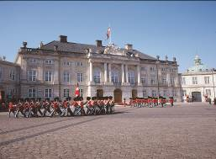
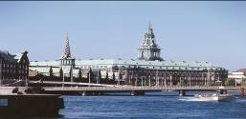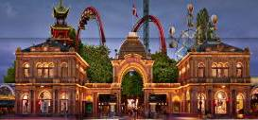
The Copenhageners excel in combining simple and sustainable solutions with a casually sophisticated lifestyle. A lifestyle based on tradition, history and culture, yet constantly moving forward, giving Copenhagen a unique blend between the harmonies of old world charm and the progressive beat of a truly cosmopolitan city.

The restaurant scene in Copenhagen is an attraction in itself. From reasonably priced bistros to Michelin-starred places. One thing you can be sure of is the focus on high quality, seasonal ingredients and an unpretentious take on dining out.
Just a decade ago Nordic gastronomy was not exactly talk of the town. This has changed dramatically, and one of the main reasons is restaurant Noma. Four times winner of the title Best Restaurant in the World, in 2010, 2011, 2012 and 2014, Noma epitomises the New Nordic wave which has echoed around the world.
The New Nordic Kitchen has its own manifesto, written in 2004 by the The New Nordic Cuisine Movement, comprised of leading Nordic chefs such as Claus Meyer and René Redzepi.

Copenhagen is a city by the sea with water running through the old canals, with lakes, beaches and harbour baths. Indeed water is an ever present element, and most Copenhageners could not imagine life without it.
Life in Copenhagen is lived by, on and in the water. During the summer months, you will find Copenhageners seeking out the sun at the city beaches and beach bars, swimming in the clean water inside the harbour baths and kayaking around the canals. Even in winter, cool winter bathers dip themselves in the harbour.

With the tourist attractions, interesting restaurant scene, great weather, and the possibilities of taking a swim in the harbor or at the beach, Copenhagen is the perfect holiday destination. With the world archery championship in late July and early August, Copenhagen is the obvious choice of destination for the summer holiday 2015.

Archery Venues:
The archery qualification and preliminary rounds are held in Sundby Arena, whereas the finals are held in front of the Danish Parliament.

Sundby Arena is located between 1 and 3 kilometres from the officials’ and athletes’ hotels, and just 3-5 kilometres from the city centre of Copenhagen. The finals will take place in front of the Danish Parliament in the city centre. There is public transportation just outside Sundby Arena, which makes it possible for spectators to come from Copenhagen downtown to the preliminary arena in about 10 minutes.

Transportation:
- Transportation will be provided from Copenhagen International Airport (CPH) to the official hotels, on 23, 24 & 25 July 2015.
- Transportation will be provided from the official hotels to Copenhagen International Airport (CPH), on 3 August 2015.
Local transportation will be available between official hotels, practice and competition venues. Transport timetables will be confirmed and provided. Buses and/or vans will be provided.

Cancellations & Changes:

Name change (the same category and division) will be accepted up to 72 hours before the event, without any additional charge. The LOC should be informed about any changes immediately in the travel programme 72 hours prior to arrivals. If your arrival is later than originally scheduled, the room charges will start from the original date indicated by the accommodation forms received from the Member Association.

Training:
There is a training field that will be available to use from 24 July 2015. The training field is walking distance to the competition field. If desired another training field will be available the 21 July – 23 July 20-25 minutes from the hotels. If you wish to use this option please contact the LOC by e-mail to: louis@archery2015.com

Weather:
July (Average): August (Average):
Temperature 22º C Temperature 20º C (68 F)
Low Temperature 15º C Low Temperature 14º C (57 F)
High Temperature 29º C High Temperature 29º C (79 F)
Sunshine Hours- 8 Hours Sunshine Hours- 7 Hours
Rainfall days- 10 days Rainfall days- 10 days

Ceremonies:
Details to be provided.

Water on the Venue:
Bottled water will be provided on the field during competition for accredited people.

Media Registration:
Media representatives can apply for registration by emailing info@archery.org.

Internet Connection:
Free WiFi will be available in official hotels and in the archery venue.

LOC Contact:
Name: Louis Gjøe Larsen – Event and Accreditation Manager
Email: hotels@archery2015.com
Language: English
Official website: www.archerycopenhagen.com
Facebook: www.facebook.com/archery2015

VISA

All participants who need an entry visa to Denmark, are kindly requested to fill in the Visa Support Form below and return completed to the Organising Committee, as soon as possible, but no later than 26 May 2015.

After the Visa Support Form is received, an official invitation, from the Danish Archery Federation, will be provided for visa application. Participants should obtain their visas before departure to Denmark. Teams and officials from countries with no diplomatic relations with Denmark are kindly requested to inform the LOC of where they prefer to apply for the visa in the third country.

NOTE: Please read the “Visa Information for Foreigners: for having a Danish Visa. Please make your visa application in person and at least one month before travelling to Denmark to avoid any difficulties.

Explanations:
You must normally meet the following basic conditions in order to be granted a visa:
- Your passport or other form of valid travel document must be valid for three months past the visa expiration date. Moreover, the passport or travel document must have been issued within the past 10 years.
- You must have the necessary means to pay for your stay and return trip. What will be considered as necessary funds will be determined by the Danish diplomatic mission and depends on the length of your stay, and whether you will stay at a hotel or with friends or family.
- You must hold a travel insurance policy to cover possible expenses in connection with a return for health reasons or death, indispensable medical treatment or acute hospitalisation during your stay. The insurance policy must cover all Schengen countries, and the minimum policy coverage is €30,000. The insurance policy must be valid for the same period as the visa. The validity of the visa may be shortened if the insurance policy does not cover the entire period.
- You may not be registered as an undesirable in the Schengen Information System (SIS).
- You may not have been deported from Denmark and given an entry ban.
- You may not be listed on UN or EU sanction lists.

For detailed information, please visit the following website from the Danish foreign offices.
http://www.nyidanmark.dk/en-us/coming_to_dk/visa/visa.htm
Visa Support Form:

All participants who need an entry visa to Denmark, are kindly requested to fill in the Visa Support Form and with copies of passports returned to the Organising Committee, as soon as possible, but no later than 26 May 2015.

Only e-mail is accepted to hotels@archery2015.com

Gender  M/F. | Family Name | Given Name | Date of Birth DD/MM/YY | Nationality and place of birth | Title  (Athlete/Coach/Official) | Passport No. | Expiration Date of Passport  DD/MM/YY | Location of Visa collection

