Dear President,

As the chair of the Organizing Committee of the first stage of Asia Cup to be held on 14th to 19th March 2023. I would like to invite you all to the most important archery events which takes place in Taoyuan, Chinese Taipei.

Taoyuan is perfectly suited for hosting this event. Since we have hosted 2017 Universiade and many archery events, now we are ready to host the 2023 Asia Cup Stage I - World Ranking Tournament.

Taoyuan city nearby Taipei City and New Taipei City. It is made up of mostly plains, interconnected mountains and plateaus. It has a deeply ingrained culture of service based on the friendliness, respect and warmth of its people. Local government and institutions are fully committed to the city’s development. Its modern infrastructure offers absolute comfort when hosting international class events.

Please find enclosed the necessary information for the event. We are looking forward to welcoming you and your team.

“Come and discover hundreds of reasons to visit and endless excuses to come back”. Sincerely yours,



Peter CHIU
OC President of 2023 Archery Asia Cup, Stage I
IMPORTANT DATES

Please find enclosed detailed information regarding this event. To register participation, please complete all the necessary sections in WAREOS (https://extranet.worldarchery.sport) within the deadlines listed below.

Summary of deadlines:

Registration Opening date on WAREOS 28th September 2022 Preliminary Entries 14th December 2022
Final Entries 21st February 2023

Late entries fee 4th March 2023

Hotel reservation down-payment (50%) 21st February 2023
Hotel reservation and payment 21st February 2023
Transportation 21st February 2023

Visa support 13th January 2023

Full refund cancellation deadline

*After this deadline, the LOC is allowed to retain all amounts due by the Member Association.
4th March 2023

Please respect the stated deadlines.

PRELIMINARY PROGRAMME

13th – 14th March 2023 Arrival of participants

15th March 2023 Wednesday

Official Practice
Team Manager's Meeting Equipment Inspection Opening Ceremony

16th March 2023 Thursday

Qualification Round
(Recurve, Compound)

17th March 2023 Friday

Team / Mixed Team Eliminations & Finals (Till Semi-Finals 1/2)
(Recurve and Compound)

18th March 2023 Saturday

Individual Eliminations (Till Semi-Finals 1/2)
(Compound, Recurve)

19th March 2023 Sunday

Finals
(Compound, Recurve)

Award Ceremonies

20th March 2023 Monday
Departure of teams

NOTE: This preliminary programme is subject to change according to participation and TV requirements. All changes will be published and distributed in good time.

PRELIMINARY & FINAL REGISTRATION
All entries, accommodation reservations, transport needs, flight arrival/departure information and visa invitation letter requests are to be completed using the World Archery Online Registration System WAREOS https://extranet.worldarchery.sport. This system handles the entire registration process for this event. No entry forms, hotel reservations or transportation forms will be accepted; all information must be entered into WAREOS.

Member associations can login to WAREOS at http://extranet.worldarchery.sport with the username and password assigned by World Archery. After entering WAREOS, selecting the event from the list will allow a member association to register their athletes. Select/press the “Entries” button to see the list of categories in the event. Select/press the “category” to enter the athlete and official numbers/details participating for that event. A WAREOS User Manual can be downloaded in PDF format (English) upon login.

Contact wareos@archery.sport with any questions regarding technical problems on WAREOS. For any question regarding the organization of the event (transport, accommodation, meals, invoices, visa etc.) please contact directly the LOC.

Athletes from a minimum of 4 different Member Associations shall be registered and participate in the event.

A maximum number of four (4) athletes per country can be registered into each category and divisions of the event.

Member Associations can only use WAREOS to make any changes or amendments to entries and will be able to do so at any time. An email will automatically notify the Organising Committee and Member Association of any changes made in WAREOS.

ENTRY FEES

Individual 150 USD per athlete

Official 100 USD per person

Any changes made after the deadlines specified or if entries differ by more than 4 athletes from the preliminary entries, the following penalty fees to will automatically be applied:

PENALTY FEES TO BE PAID TO ORGANISING COMMITTEE

Penalty fees for Late Entries (after final deadline): 50 per entry

Penalty fees for not filling Preliminary entries 50 per entry

Penalty fee for differences between preliminary and final entries:
*If the difference between final and preliminary entries number is more than 4 athletes/officials
50 per entry

PENALTY FEES TO BE PAID TO WORLD ARCHERY (CHF)

Any change to the final country entry list, such as (but not limited to):
- Athlete or official name change
- Date of birth change
- Official position change
- Absence or incomplete on-site contact person
50.- each change

NOTE: CHF currency exchange rates will be those on the date of the event.

ACCOMMODATION

Fourpoints by Sheraton Linkou – 4 Star Hotel
- Single Room price: USD300.00 per room
- Number of rooms: 0
- Double/Twin Room price: USD400.00 per room
- Number of rooms: 40
- Board plan: full board
- Check-in from 13 March 2023 – 15:00
- Late check-out 20 March 2023 – 12:00
- Hotel website: https://myclubmarriott.com/hotel/hoteldetail/co/four-points-by-sheraton-linkou

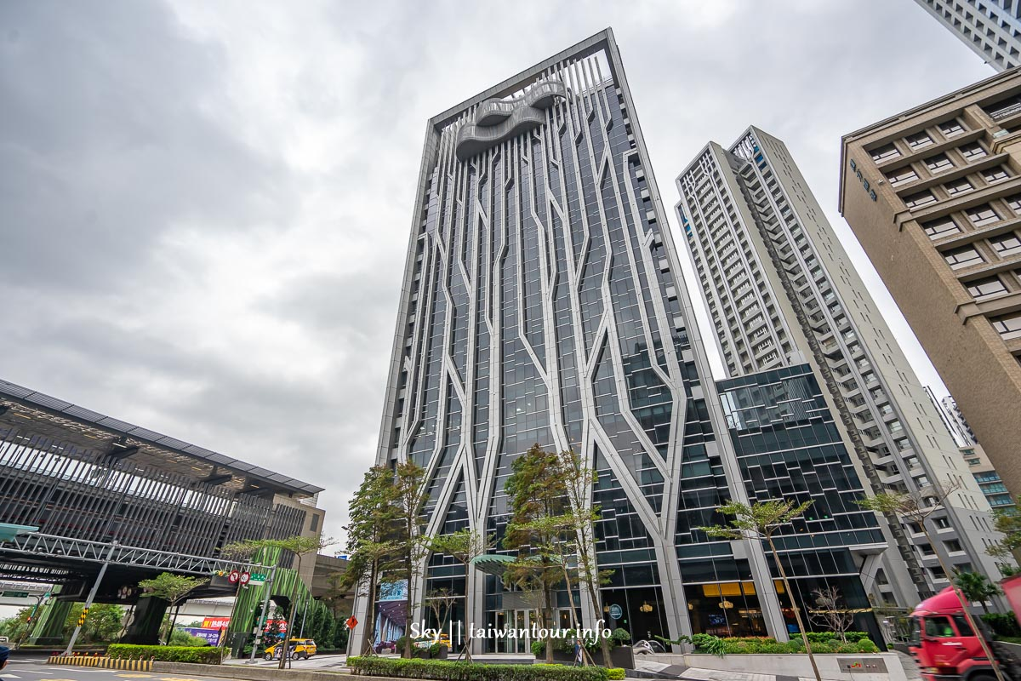
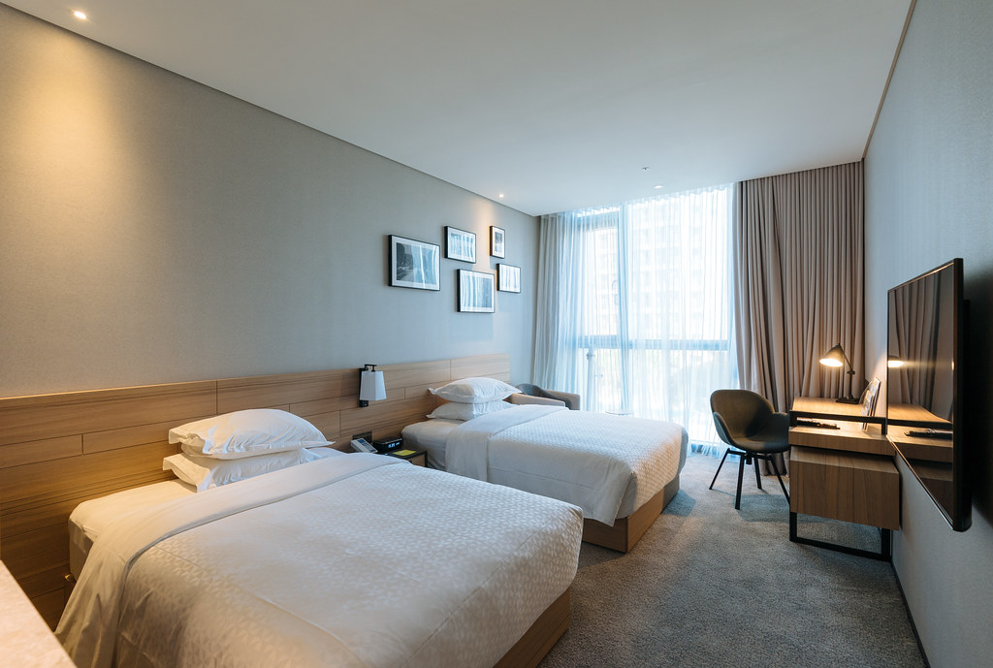
(15 minutes by car to the venue)

Hotel Intrendy New Taipei – 3 Star Hotel
- Single Room price: USD200.00 per room
- Number of rooms: 10
- Double/Twin Room price: USD270.00 per room
- Number of rooms: 60
- Board plan: full board
- Check-in from 13 March 2023 – 15:00
- Late check-out 20 March 2023 – 11:00
- Hotel website: https://www.hotel-intrendy.com/
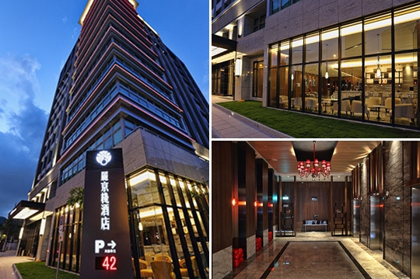
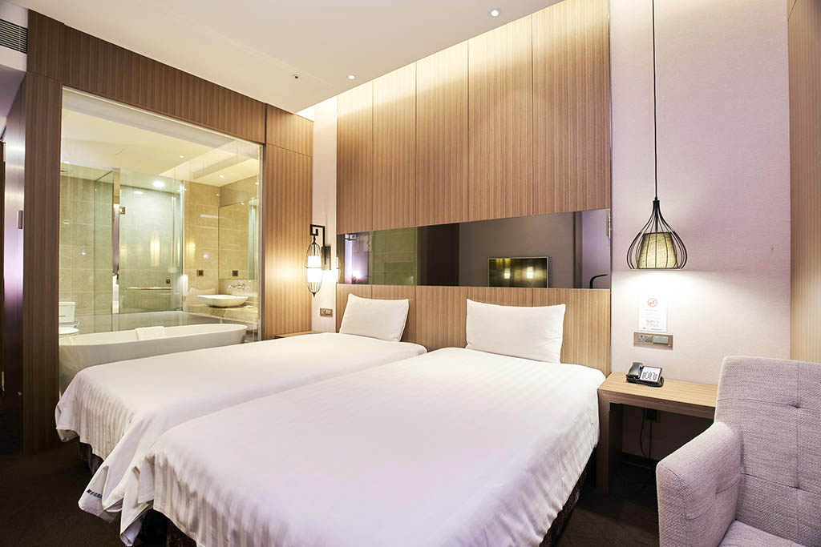

(20 minutes by car to the venue)

HIGHNESS HOTEL– 3 Star Hotel
- Single Room price: USD200.00per room
- Number of rooms: 10
- Double/Twin Room price: USD270.00 per room
- Number of rooms: 60
- Board plan: full board
- Check-in from 13 March 2023 – 15:00
- Late check-out 20 March 2023 – 11:00
- Hotel website: https://highnesshotel.ezhotel.com.tw/

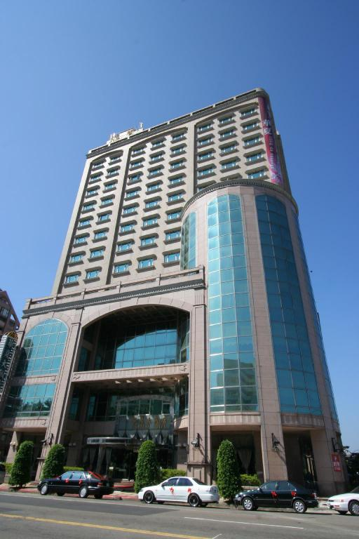
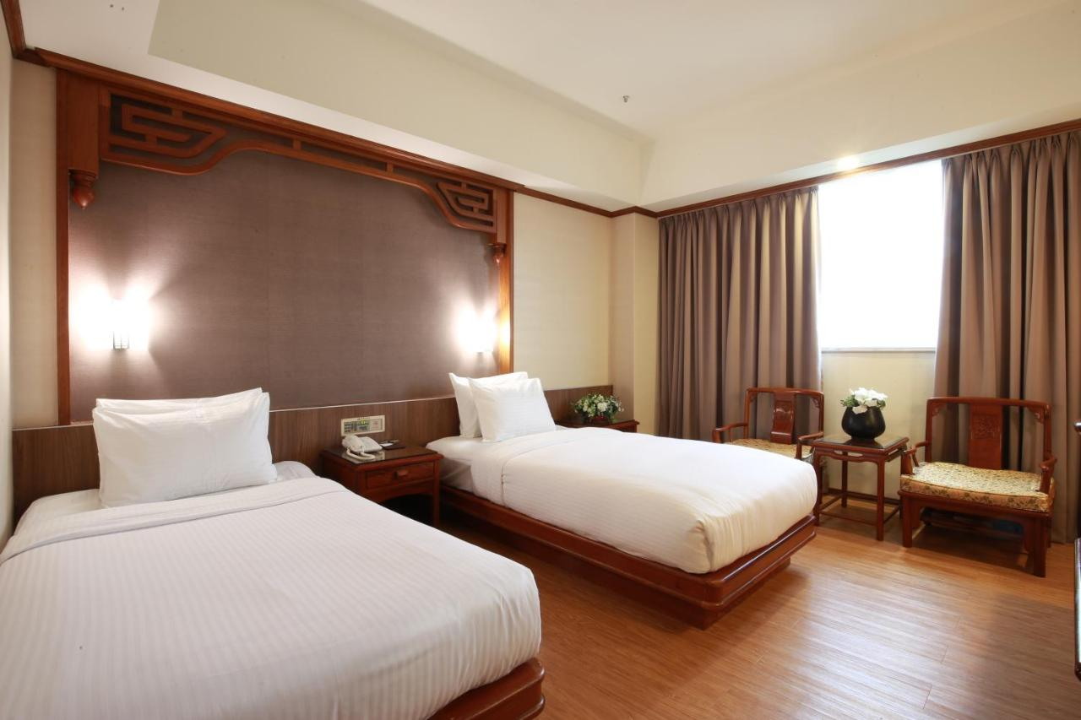

(15 minutes by car to the venue)

Hotels are allocated on a first come, first serve basis. Full-board option is included. Due to sanitary restrictions, all teams MUST book their accommodation through the organizing committee.

TRANSPORTATION
Transportation will be provided from Taoyuan airport / Taipei Song-Shan airport to the official hotel, from two days before the official practice day and until two days after the closing day for free. Local transport will be available between the official hotel, practice and competition venues for free. Transport timetables will be confirmed.

VISA
All participants who need an entry visa to Taipei, will be required to complete the Visa Support sections in WAREOS by no later than 13 January 2023.

It is the applicants’ responsibility for supplying the necessary information, ensuring all details are up to date, correct and submitted by the deadlines specified.

In addition, all participants that require a visa are kindly requested to supply a copy of their latest/valid passport. Copies of each application can be uploaded on WAREOS. All passport copies and personal details entered/uploaded to WAREOS will be held securely and in the strictest of confidence and not shared with other parties.

PAYMENT CONDITIONS
Complete all necessary sections in WAREOS and make full payment by the specified deadlines. Bank transfers only, no credit cards will be accepted. All bank charges will be paid by the participants.

The entry fees should be paid in full before arrival.

To confirm hotels reservations, a minimum 50% deposit of the total amount is required to be bank transferred to the OC before 21 February 2023. Reservations after this date will be considered only according to availability. The final outstanding balance shall be made via bank transfer before arrival. Accommodation cannot be guaranteed after this deadline. A balanced invoice will be provided via WAREOS.

BANK INFORMATION FOR ACCOMMODATION, TRANSPORTATION AND ENTRY FEES
A/C Name: Chinese Taipei Archery Association Federation’s Address: R701, No.20, Chu-Lun St., Taipei, Taiwan. Telephone number: +886-2-2721-6182
Bank: TAIWAN SHIN KONG COMMERCIAL BANK
Account Number: 0143118886868
Swift: MKTBTWTP523
Bank’s address: No. 36, Songren Road, Xinyi District, Taipei, Taiwan.
Bank’s Phone: +886-2-8758-7288

NOTE: ALL PAYMENTS SHALL BE MADE IN USD.

CANCELLATIONS & CHANGES
All cancellations and changes must be made through WAREOS:

- Should flight arrival details change last minute, please contact the Organising Committee using the details indicated in the team managers’ booklet.
- If a participant’s arrival is later than the original scheduled arrival date, the room will be charged from the date of the original booking in WAREOS.
- An email will automatically notify the Organising Committee and Member Association of any changes made in WAREOS.

HEALTH REGULATIONS (COVID-19)

INFORMATION
- Everybody should follow the Government/public health authorities measures (national and sport-specific regulations) and be aware of the travel restrictions
- For your information, Medical infrastructure/Hospital with proper care will be reachable within 15 minutes from the venue, where COVID-19 test can be done.

MEDICAL EMERGENCY CONTACT AND LOCATION
CHANG GUNG MEMORIAL HOSPITAL, Linkou.
No.5, Fuxing St., Guishan Dist., Taoyuan City
+886-3-3281200

ADDITIONAL INFORMATION TRAINING
A training field will be available starting on 14 March 2023 at the NTSU Stadium located
approximately 15 to 50 minutes from the official hotels.

WEATHER
Temperatures in March are expected to range between 17 and 25 degrees Celsius. The average in the last few years has been 19 degrees Celsius.

MEDIA REGISTRATION
Media representatives can apply by emailing at ctaaint@gmail.com (LOC media contact)

INTERNET
Will be available in the official hotels for free (in hotel rooms and in the lobby). There will also be Wi- Fi available for access to results on venue.

WATER
Each participant with receive clean bottles of water.
Bottled water will be available at the qualification and practice venues.

LOC CONTACT
Name: Tzu-Yun LIN
Address: R701, No.20, Chu-Lun St., Taipei, Taiwan Email: ctaaint@gmail.com
Language: Chinese and English

Phone number with international extension: +886-2-2721-6182 Looking forward to welcoming you in Taoyuan, Chinese Taipei.

