TO ALL World Archery MEMBER ASSOCIATIONS

Dear President,

On behalf of the Organising Committee (OC) of the Hyundai Archery World Cup 2017, Berlin – Germany and the German Shooting Sport and Archery Federation, we would like to invite your country to the Hyundai Archery World Cup 2017, which will be held from 8 to 13 August in Berlin, the capital of Germany.

To register participation, please complete all the necessary sections in WAREOS within the deadlines listed below:

Summary of deadlines:

- Preliminary Entries 10/05/2017
- Final Entries and entry payment 18/07/2017

- Preliminary Hotel Reservation 28/04/2017
- Final Hotel Reservation &Deposit 06/06/2017
- Remaining Hotel Payment 18/07/2017

- Visa Support 06/07/2017
- Transportation 06/07/2017

We are looking forward to welcoming you and your teams, to Berlin – Germany.

Sincerely yours,


Gerhard Furnier
Chairman of the Organising Committee

PRELIMINARY PROGRAMME:
Day | Date | Description
DAY -1 | Sunday  6 August | Arrival of Participants  Unofficial practice  Transport available
DAY 0 | Monday  7 August | Arrival of Participants  Unofficial practice  Transportation available
DAY 1 | Tuesday  8 August | Official Practice (For all)  Equipment Inspection  Team Managers Meeting 16:00 at TBC
DAY 2 | Wednesday  9 August | Qualification Round for Recurve and Compound  (Recurve 70m Round and Compound 50m Round)  Mixed Team Eliminations 1/8 – seminfinals
DAY 3 | Thursday  10 August | Individual Eliminations for Recurve and Compound  Morning 1/48 and 1/32  Afternoon 1/16 to semifinals
DAY 4 | Friday  11 August | Team Eliminations for Recurve and Compound  1/8 – seminfinals
DAY 5 | Saturday  12 August | Finals Compound – Individual and Team  - Compound (Women and Men)  - Award Ceremonies
DAY 6 | Sunday  13 August | Finals Recurve – Individual and Team  - Recurve (Women and Men)  - Award Ceremonies
 | Monday  14 August | Departure of Participants

NOTE: This is a preliminary programme and subject to change according to the number of participants in each division and TV requirements. All changes will be published and distributed to all participants in advance.

PRELIMINARY & FINAL REGISTRATION
All entries, accommodation reservations, transport needs, flight arrival/departure information and visa invitation letter requests are to be completed using WAREOS.

The World Archery Online Registration System (WAREOS): http://register.worldarchery.org has been updated to handle the entire registration process for this event. No entry forms, hotel reservations or transport forms will be accepted as all information is to be entered into WAREOS.

In order to use WAREOS, please login on http://register.worldarchery.org with your Username and Password assigned by World Archery. After entering WAREOS, please find the event, from the list, you wish to register your athletes. Select/press the “Entries” button to see the list of categories in the event. Select/press the “Category” to enter the athlete and official numbers/details participating for that event. A "WAREOS User Manual" can be downloaded in PDF format (English) using the same website link.

For any questions regarding the WAREOS, please contact the World Archery office, Mr. JK LEE (jklee@archery.org).

A maximum number of 4 athletes per country is allowed to be registered into each category of the event. Preliminary entries should be completed using WAREOS.

Start date for online registration using WAREOS 25 January 2017
End of Preliminary registration using WAREOS: 10 May 2017
End of Final registration using WAREOS: 18 July 2017

Please respect the stated deadlines.

Member Associations should only use WAREOS to make any changes/amendments to their entries and will be able to do so at any time. Any changes made in WAREOS an email will instantly be automatically sent to the Organising Committee and Member Association with the updated information.

However, any changes that are made after the deadlines specified or if entries differ by more than 4 athletes from the preliminary entries, the following penalty fees will automatically be applied.

Penalty fees to be paid to Organising Committee: | Cost (EUR):
Entries made after the preliminary and/or final entry deadline date. | 45 per entry
If final entries differ from the preliminary entries by more than 4 athletes/officials. | 140 per entry
Failure to have made preliminary entries before the deadline date but then have submitted final entries. | 140 per entry

Penalty Fee to be paid to World Archery: | Cost (CHF):
Lost accreditation. | 30 each
Changes made to the athlete and/or team official names after the final entry deadline date and within 3 days prior to the start of the event. | 50 each change

NOTE: CHF currency exchange rates will be those on the date of the event.

Member Associations that have penalty fees outstanding from 2016 will need to have paid these penalty fees before being eligible to enter and compete.

Any entries received less than 3 days before the team managers meeting for a Hyundai Archery World Cup or World Championships will be refused if no preliminary entry and/or final entry are made prior. This decision cannot be appealed by the teams and is fully compliant with the current World Archery rules, article 3.7.1.2. Entries received after the deadlines, are subject to penalties as clearly stated in the rule book and the invitation documents of World Cups and World Championships. A Member Association that has made final entries in WAREOS and does not participate will be invoiced for the number of entries entered in the system, unless they have informed World Archery and the OC in writing at least one week prior to the event that they are unable to attend

ACCOMMODATION
Teams who do not reserve their accommodation through the LOC will be charged a double entry fee. 300 euro (per athlete)/200 euro (per official) and will not be entitled to any event information or transportation.

- Preliminary Hotel Reservation 28/04/2017
- Final Hotel Reservation & Deposit 06/06/2017
- Remaining Hotel Payment 18/07/2017

IMPORTANT! Please note that there will be a limited number of rooms at each hotel. To ensure that you stay at your preferred hotel, please make your hotel reservation in WAREOS ASAP. Note, that the reservation is final only after the OC has received 80% deposit. The principle of “first come, first served” will be used. Also note that it will not be possible to refund the deposit after 6 June.

The hotel room rates are per room, per night, including free internet (except Park Inn Berlin Alexanderplatz), full board, breakfast and dinner at the hotels, lunch will be served at the venue. Meals include water. Additional purchases in the hotel bar, café and minibar is at own expense. Please refer to accommodation pages below for detailed hotel information. Hotels are rated in German categories.

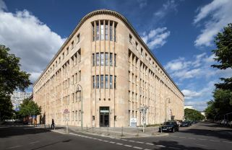
4* SUPERIOR CATEGORY CENTER
Crowne Plaza Berlin Potsdamer Platz
www.crowneplaza.com/potsdamerplatz

EUR 155,00 / single incl. full board
EUR 240,00 / double incl. full board

The Crowne Plaza Berlin - Potsdamer Platz welcomes you in the midst of the political and cultural scene of Berlin, near the Brandenburg Gate and Checkpoint Charlie. The hotel owns 256 contemporary rooms with smart TV-systems, free WIFI and luxurious bathrooms, a restaurant with outside terrace and a trendy bar .If you are looking for silence and relaxation you will find an inviting spa area with sauna, steam room and relax-shower. A good work out awaits you in the 24-hour fitness lounge with state-of-the-art equipment.

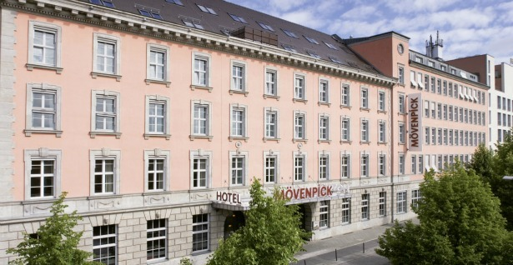
4* HOTEL CENTER
Mövenpick Hotel Berlin Potsdamer Platz
www.moevenpick-hotels.com/berlin

EUR 150,00 / single incl. full board
EUR 230,00 / double incl. full board

Combine a touch of history with modern accommodation and personal service when you stay at Moevenpick Hotel Berlin. The 4-star hotel in central Berlin is located near Potsdamer Platz in the city centre, just 100 metres from the Anhalter Bahnhof S-Bahn train station and 25 minutes from Berlin Tegel Airport. Stylish interiors complement modern technology in the 243 hotel rooms, many with views over Berlin or the quiet courtyard. Unwind in the gym and sauna before enjoying freshly-prepared seasonal produce in the glass-roofed restaurant and bar. The hotel owns 2 rooms especially suited for physically challenged guests as well as 2 barrier-free rooms. Free WIFI is included.

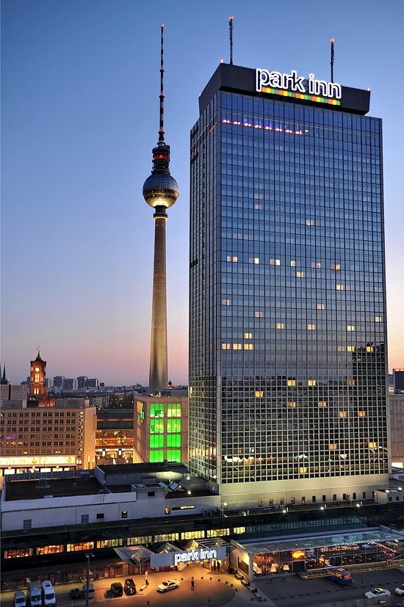
4* HOTEL CITY AREA
Park Inn Berlin Alexanderplatz
www.parkinn-berlin.de
EUR 130,00 / single incl. full board
EUR 210,00 / double incl. full board
With its 1012 rooms & suites on 37 floors and a total height of 150m, the Park Inn by Radisson Hotel Berlin Alexanderplatz is the second largest hotel in Germany and the tallest hotel in Berlin. A hotel of superlatives and next to the Berlin TV Tower a central landmark at Berlin’s Alexanderplatz Square. The hotel is situated in a central location with many amenities and facilities such as the Precious Spa & Fitness, 3 different restaurants, Bar & Lounge offering Euro-Californian cuisine and live music, publicly accessible rooftop terrace and the world’s fastest passenger cable wind. The Rooms are equipped with high-quality furnishings and a modern design in warm, elegant wood tones, bathrooms with showers, WC and hairdryer. A flat screen TV and high-speed internet access (chargeable), soundproof windows and air conditioning is standard in all hotel rooms.
WIFI is available but not free of charge (bookable directly in the hotel)

Important Note:
Please refer to the accommodation pages below for detailed hotel information. Please complete all necessary sections in WAREOS, make full payment for entries and accommodation by the specified deadlines. Bank transfers only, no credit cards or travel checks will be accepted.

Participants who book their accommodation in non-official hotels will need to pay a double entry fee. In addition, the LOC will not be responsible to provide any event information at this hotel or provide transportation to the venues.

Teams that book non-official accommodation will need to register at the accreditation desk no later than the day before official practice day. Failing to do so will result in no changes being made to the entry list and it is likely that participation in the event will be refused, if registration is not completed in time.

PAYMENT CONDITIONS HOTELS:
To confirm your hotel reservations, an 80% deposit, of the total amount, is required to be transferred, to the HK Travel Plus GmbH before 6 June 2017, via a bank transfer, using the details below. The remaining payment for accommodation should be paid by 28 July 2017.

Accommodation cannot be guaranteed after this deadline. In case of cancellation after 6 June 2017 and/or a no-show, the travel agency will charge a cancellation fee of 100% of the costs for all nights and rooms you have booked.

BANK INFORMATION for ACCOMMODATION
HK Travel Plus GmbH (Frauenlobstraße 97, 55118 Mainz)
Volksbank Alzey-Worms eG (Breite Straße 23 - 27, 55124 Mainz)
IBAN DE 15 5509 1200 0080 518307 BIC GENODE61AZY

PLEASE DO NOT MAKE HOTEL PAYMENTS TO THE ORGANIZING COMMITTEE

Contact to Travel Agency
hk travel plus GmbH Phone: +49-6131-217098-0
Mrs. Birgit Huhn Fax: +49-6131-217098-20
Frauenlobstraße 97 E-mail: birgit.huhn@hktravelplus.de
55118 Mainz, Germany Web: www.hktravelplus.de

GENERAL INFORMATION
Archery Venue:
The archery qualification, elimination round will be held at the Maifeld Glockenturmstrasse 1, 14053 Berlin. The venue is located behind the famous Olympic Stadium.

The medal finals will be held at the Lilli-Henoch Sportplatz, Askanischer Platz Schöneberger Str. 34, 10963 Berlin in the center of Berlin.
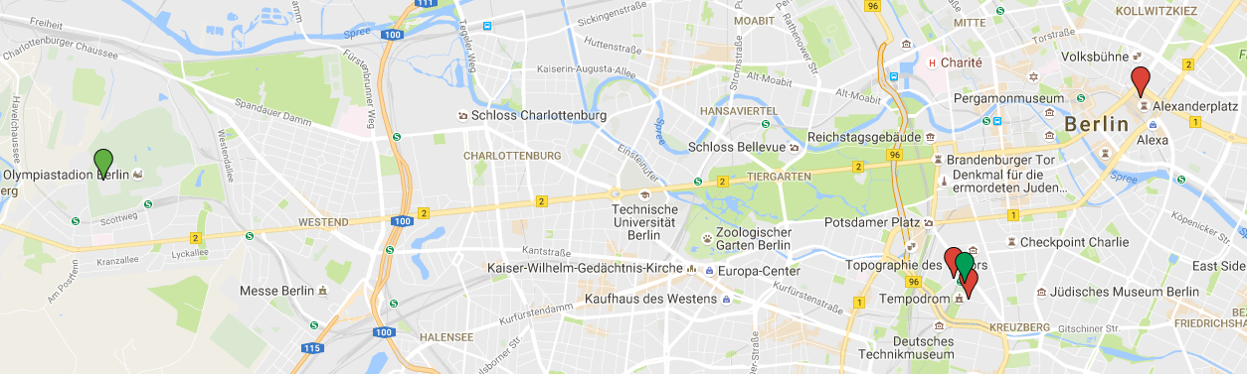
Qualification venue
Park Inn Hotel
Final venue
Crown Plaza Hotel
Moevenpick Hotel
Distances in Berlin:
Maifeld (Qualification Venue) Anhalter Bahnhof (Finals Venue)
Hotels Potsdamer Platz 13 km; 30 min walking distance
Park Inn Berlin Alexanderplatz 14 km, 35 min 4 km, 15 min

Transportation:
- Transportation will be provided from Tegel (TXL) and Schoenefeld (SFX) airports to official hotels, on 6 & 7 August 20167.
- Transportation will be provided from the official hotels to Tegel (TXL) and Schoenefeld (SFX) airports on 14 August 2017.
- Airport Transportation fee is 20 Euros per person for both ways.

Local transportation will be available between official hotels and the competition venue. Transport timetables will be confirmed and provided. Buses and/or vans will be provided. Additionally the accreditation includes free use of the public transport in Berlin (BVG).

Cancellations & Changes:
Name change (the same category and division) will be accepted up to 72 hours before the event without any additional charge. OC should be informed about changes in the travel program 72 hours prior arrivals. If your arrival is later than your original schedule, the room charges are starting from the original date indicated by the Member Association in their accommodation reservation.

Training:
A training field will be available starting from 06 Aug 2017. The training field is next the competition field. Transportation between the hotels and the venue will be provided.

Water on the Venue:
Bottled water will be provided on venue during competition for accredited persons.

Media Registration:
Media representatives can apply for registration by emailing info@archery.org.

Internet Connection:
Free Wi-Fi will be available in the official hotels (except Park Inn). There will also be Wi-Fi available for access to results.

Weather:
August (Average):
Average Temperature 23 º C
Low Temperature 12º C
High Temperature 30º C
Sunshine Hours 7 Hours
Rainfall days 8 days
Sunrise 6.00h
Sunset 20.00h

VISA SUPPORT
All participants who need an entry visa to Germany, will be required to complete the Visa Support Form in WAREOS by no later than 06 July 2017.

It is the applicants’ responsibility for supplying the necessary information, ensuring all details are up to date, correct and submitted by the deadlines specified.

In addition, all participants that require a visa are kindly requested to supply a copy of their latest/valid passport. Copies of each applicate can be uploaded on WAREOS. All passport copies and personal details entered/uploaded to WAREOS will be held securely and in the strictest of confidence and not shared with other parties.

Please note that the Organizing Committee can provide invitation for the period of the World Cup in Berlin only.

LOC Contact:
Name: Mrs. Claudia HESS, Registration Manager
Email: info@worldcup-berlin.de
Language: German, English
Official website: www.worldcup-berlin.de

Entry fee:
Individual: | 150 EUR per athlete
Officials: | 100 EUR per person
Temporary Upgrade:  For athletes wishing to be a coach temporarily | 25 EUR per accreditation

Entry fee in NON official hotels:
Individual: 300 Euro per athlete
Officials: 200 Euro per person

Airport Transportation Fee:
Roundtrip 20 Euro per person

For participants using official hotels, entry fees include daily local transport to/from the practice field to official hotels during qualification, elimination and finals (timetable to be confirmed). All participants should book their accommodation through the LOC.

Participants that do not book their accommodation through the LOC, will have to pay double entry fees and will not be entitled to any event information or transportation

Payment of Entry Fees
All Entry Fee and Transportation payments must be made to the Organizing Committee.
The LOC will send an invoice to each delegation after the final entry deadline.
The deposit for the entry fee must be transferred to the following bank account:

Account holder:
German Shooting Sport and Archery Federation / Deutscher Schuetzenbund e.V.
Lahnstr. 120
65195 Wiesbaden, Germany

Account:
Wiesbadener Volksbank
Schillerplatz 4
65185 Wiesbaden, Germany

IBAN DE16 5109 0000 0008 8088 80
BIC WIBADE5W

